Name: ____________________ Period: ____ Date: ________

Worksheet: Tracing Our Paths

Part I
You just spent some time as a carbon atom moving around a simple ecosystem. You probably moved from the atmosphere pool to the producer pool. Some of you may have become part of an herbivore, carnivore, or decomposer. Each of you took unique paths through the ecosystem. What does that path look like in a real ecosystem?

- Draw some arrows that show how carbon can move from carbon dioxide in the atmosphere to organic matter in the ecosystem. Label these arrows with a #1.
- Draw some arrows that show how organic matter moves through the ecosystem. Label these arrows with a #2. Make sure your arrows include:
  - Plants
  - Rabbits
  - The fox
  - The soil
- Draw some arrows that show how carbon in organic matter can get back to carbon dioxide in the atmosphere. Label these arrows with a #3.
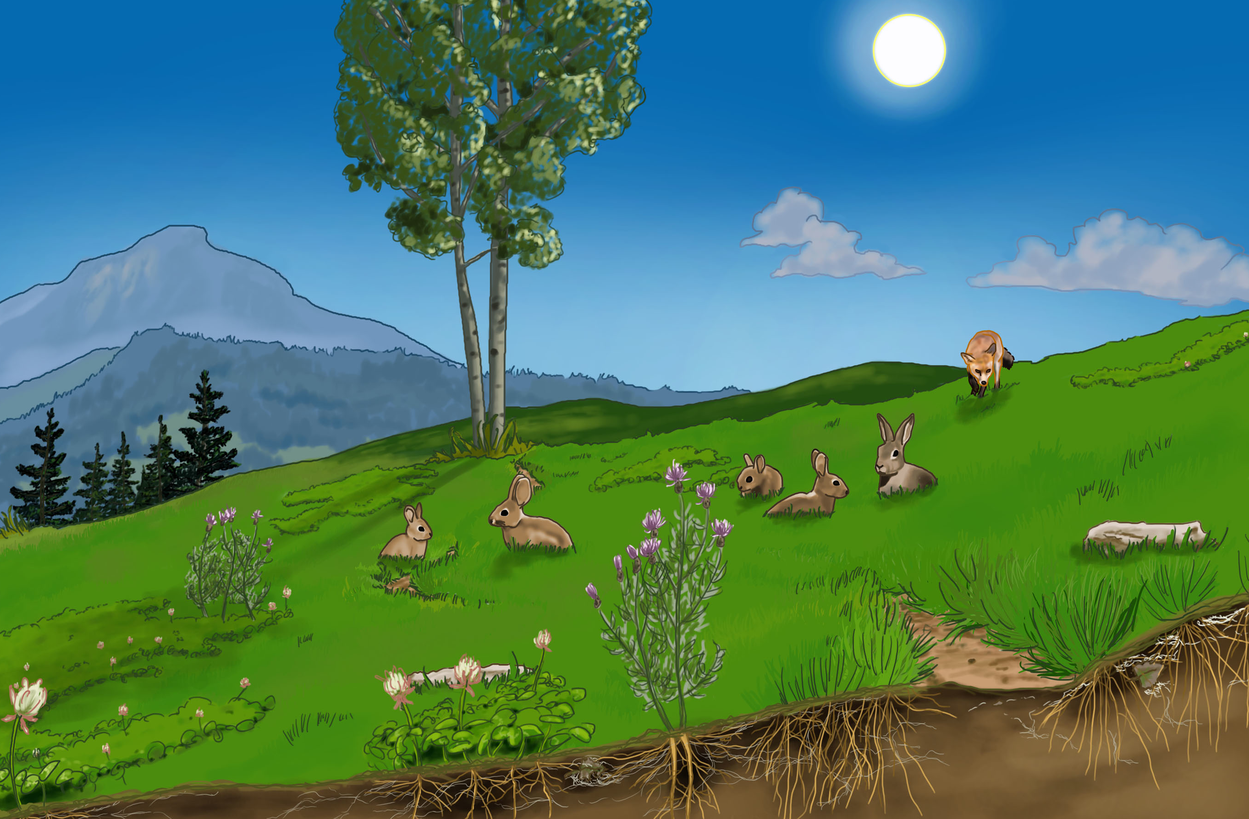
- How are the arrows labeled #1 (from the atmosphere to the ecosystem) and #3 (from the ecosystem to the atmosphere) different?

Part II
This diagram was designed to help you think about the carbon-transforming processes that the carbon atoms go through as they travel through an ecosystem. The arrows on the diagram represent carbon transforming processes or movements (also called “fluxes”), and the boxes represent locations in the ecosystem where carbon is located (also called “pools”).

- On the diagram below, draw 6 vertical lines. Each vertical line should begin in the atmosphere pool (the box on the very top) and end in atmosphere pool (the box labeled on the very bottom), passing through different arrows along the way.
- Draw a vertical line that matches each of the following paths:
  - Air➔Grass➔Air
  - Air➔Grass➔Soil➔Air
  - Air➔Grass➔Rabbit➔Fox➔Soil➔Air
  - Air➔Grass➔Rabbit➔Air
  - Air➔Grass➔Rabbit➔Soil➔Air
  - Air➔Grass➔Rabbit➔Fox➔Air
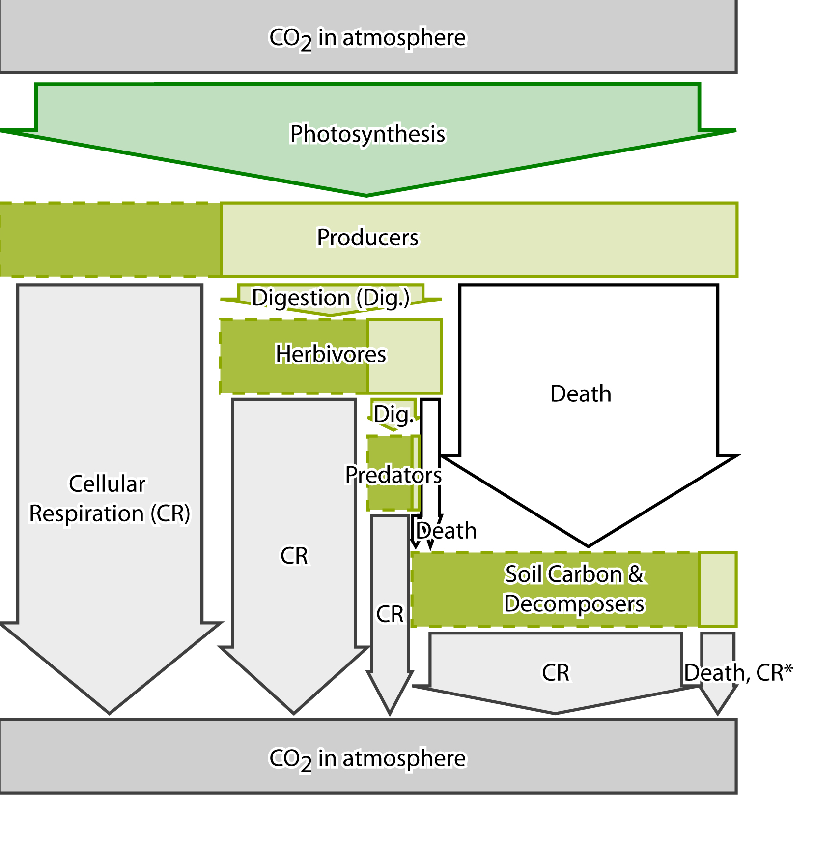

- Why do all of the lines above begin and end in the air?

- Which carbon-transforming process did you pass through every time? Why?

- Describe the carbon transforming processes that you would need to go through to follow this path: Air➔Grass➔Rabbit➔Fox➔Soil➔Air

- Describe the carbon transforming processes that you would need to go through to follow this path: Air➔Grass➔Soil➔Air

- Describe the carbon transforming process that you would need to go through to follow this path: Air➔Grass➔Air

- Which arrow in the arrow diagram above changes carbon from organic to inorganic?

- Which arrow in the arrow diagram above changes carbon from inorganic to organic?

Part III.
Some scientists say that “matter cycles, and energy flows.” When you were a carbon atom during the carbon game, you cycled through the ecosystem. You may have changed from organic to inorganic, or moved from one organism to another, but you never exited the ecosystem.

- Look at what happens to the energy in the diagram below. How is it different than matter? (Hint: the squiggley lines show things that are happening to energy).
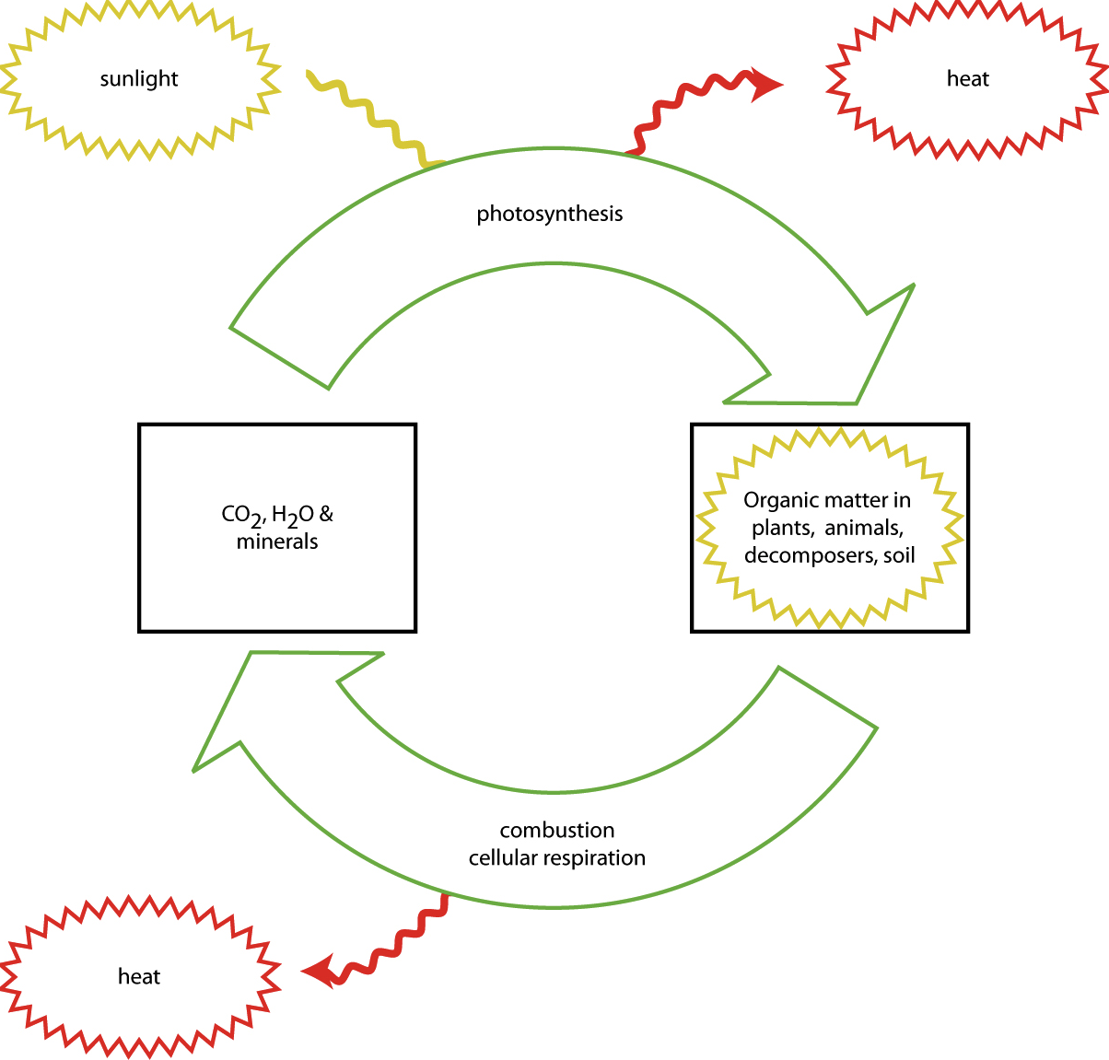
- What do you think happens to energy when things eat each other? Use the diagram below to help you construct an answer.
Part IV.
Have a look at this picture and the arrows in it. See if you can explain what the arrows mean.

Arrows 1 and 2:

Arrows 3, 4, 5, 6, and 7:

Arrow 8, 9, 10, 11, 12, and 13:

